ASSESSMENT: | GROUP ASSIGNMENT | PROGRAMME: | Diploma in ICT
MODULE CODE: | NDTA 631 | MARKS: | 100
MODULE DESCRIPTION: | Data Analysis and Visualization | DATE: | 4 August 2025
EXAMINER(S): | Melvin Kisten | DUE DATE: | 4 September 2025 (NO EXTENSIONS)
GROUP SIZE: |  | 6 to 7 students
Full Names | Student no.
1.Nomathemba Giveness Sethibi | 202218389
2.
3. Ayanda Mfusi | 202339156
4.
5. Ayabulela Zangana | 202300613
6. Onkemetse Maphunye | 202322855
7. Charmaine Shisana | 202331789

Data Analysis Report

- Introduction:

This report is based on two important datasets from the World Bank’s Data360 platform: Poverty and Inequality Platform (PIP) and Learning Poverty Global Database (LPGD). The PIP dataset provides detailed information on poverty levels, income inequality, and shared prosperity across 170 countries. It is the main tool used by the World Bank to monitor poverty trends and support global development goals, particularly those related to reducing poverty and inequality (Fujs et al., 2022).
The LPGD dataset focuses on education and measures the percentage of children who are unable to read and understand a simple text by a certain age. This is a key indicator for assessing early learning outcomes and identifying gaps in education systems.
Together, these datasets allow us to examine the relationship between poverty and education by comparing global poverty trends with learning poverty outcomes. Specifically, the report investigates whether higher levels of poverty and inequality are linked to lower educational achievement.
These two sources are highly complementary: while PIP offers insight into the economic well-being of populations, LPGD provides a snapshot of foundational educational access and quality—particularly among children in low-income settings. Analysing them together helps us understand how socio-economic conditions may influence learning outcomes. This connection is vital for exploring the long-term effects of poverty on human capital development and for designing effective education and poverty reduction policies.

2. Datasets Details

PIP (poverty and inequality platform)
- Scope:
The PIP dataset covers approximately 170 countries, offering both national and regional data spanning multiple years. It includes a wide range of key indicators, such as:
  - Poverty headcount ratio
  - Poverty gap index
  - Poverty severity (squared poverty gap)
  - Gini coefficient
  - Mean and median welfare
  - Decile income or consumption shares
  - Shared prosperity metrics
- pipr
The pipr package allows R users to compute poverty and inequality indicators for more than 160 countries and regions from the World Bank’s database of household surveys. It does so by accessing the Poverty and Inequality Platform (PIP) API. PIP is a computational tool that allows users to estimate poverty rates for regions, sets of countries or individual countries, over time and at any poverty line.
- Methodology:
  - Data Foundation: PIP builds on household surveys compiled in the Global Monitoring Database, which are coordinated regionally to ensure comparability across time and countries (pip-technical-team.github.io).
  - Poverty Calculations: Monetary poverty measures are computed using internationally comparable norms (e.g., 2011 PPP-adjusted welfare and standard poverty lines), applying formulas such as the series for microdata and specialized Lorenz-based formulas for grouped data (worldbank.github.io).
  - Inequality and Distributional Indicators: Includes Gini index, mean log deviation, polarization index, median welfare, and decile shares—all derived through established statistical methods and Lorenz-function-based approaches.
  - Interpolation: When survey data are missing for specific years, PIP uses interpolation procedures tied to national accounts trends, employing either “same direction” or “diverging direction” methods.
  - Shared Prosperity and Data Access: Shared prosperity measures focus on welfare growth among the bottom 40%. PIP also offers integrated platforms like Statistics Online that facilitate interactive analysis using tools such as Stata or Jupyter notebooks (World Bank Blogs).

WB_LPGD (Learning Poverty Global Database)
- Scope:
The Learning Poverty Global Database compiles historical data on the Learning Poverty indicator and its underlying components. It offers both national-level learning poverty rates and sub-components such as schooling denial and learning denial. Global metadata confirms that it includes data by gender and enables analysis across countries (Base dos Dados, World Bank Data Catalog).

- Methodology:
  - Definition: Learning Poverty measures the percentage of children who cannot read and understand a simple age-appropriate text by age 10. It combines two deficiencies which are schooling denial and learning denial by using the formula: LP = SD + (1 − SD) × LD (World Bank, DataBank).
  - Extended Metrics: Beyond the headcount ratio, the database also includes:
    - Learning Poverty Gap: The average shortfall in proficiency for children below the minimum level.
    - Learning Deprivation Severity: Highlights inequality among the learning-underprivileged population (World Bank).
  - Data Sources & Aggregation: The Learning Poverty measure is based on standardized reading assessments such as PIRLS, TIMSS, and regional assessments combined with adjusted net enrolment rates (World Bank, DataBank).
3. Methods:
1. Data Processing Steps
Before conducting the analysis, the datasets were prepared through the following steps:
- Data Cleaning:
  - Removed missing, duplicate, or inconsistent entries.
  - Standardized country names and date formats for alignment between datasets.
  - Converted relevant variables (e.g., poverty rates, learning poverty percentages) into consistent numerical formats.
- Data Merging:
  - Merged the Poverty and Inequality Platform (PIP) and Learning Poverty Global Database (LPGD) datasets based on country and year to create a unified dataset.
  - Ensured temporal alignment by selecting overlapping years and using consistent reference periods for both datasets.
- Data Normalization:
  - Where necessary, we normalized variables to enable fair comparisons across countries or indicators with different units.
  - Applied log transformations to variables with skewed distributions to improve interpretability.
2. Analytical Approach
We used several statistical and visual methods to examine the relationship between poverty and learning outcomes:
- Time-Series Comparison:
  - Tracked trends in poverty headcount ratios and learning poverty rates over time for selected countries and regions.
  - Visualized changes using graphs to identify patterns.
- Correlation Analysis:
  - Measured the strength and direction of relationships between key variables such as:
    - Poverty rate vs. learning poverty
- Visualization:
  - Used histograms, scatter plots, box graph and bar charts to visually represent relationships and highlight key findings.

4. Visualizations
Bar plot (showing average value of poverty and learning poverty)
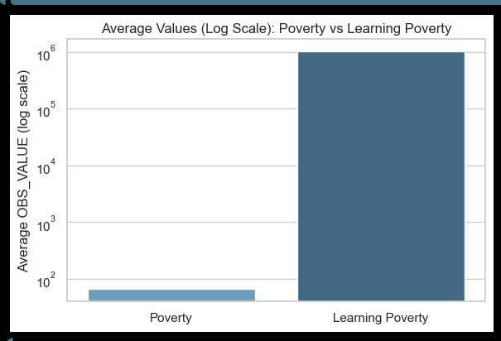
Box plot (showing distribution comparison between poverty and learning)
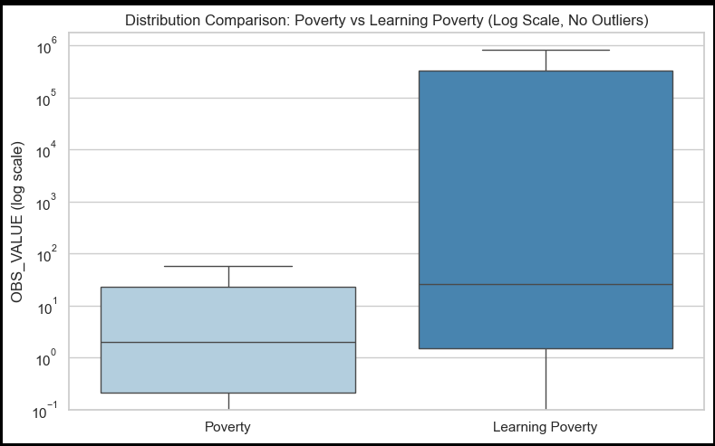
Histogram plot (showing side to side distribution frequency)
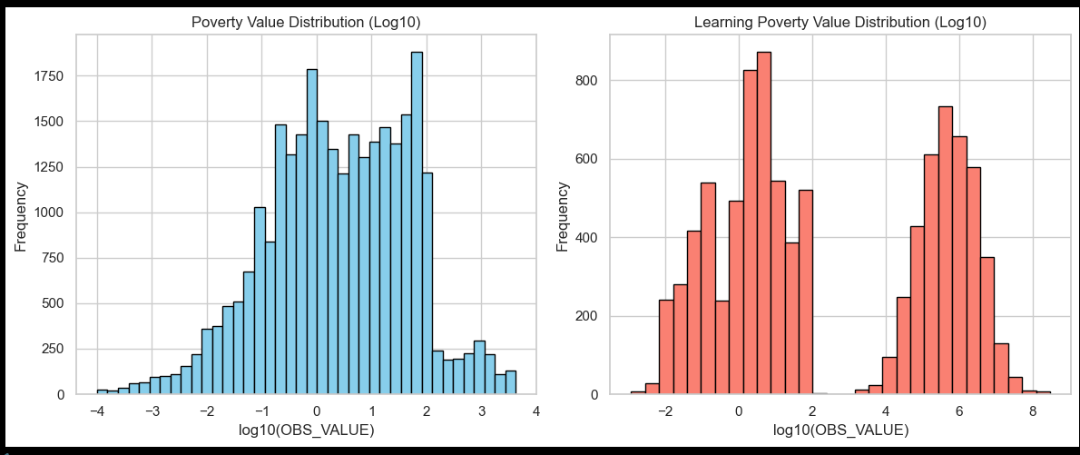
Scatter plot (obs_value of learning poverty and poverty distribution)
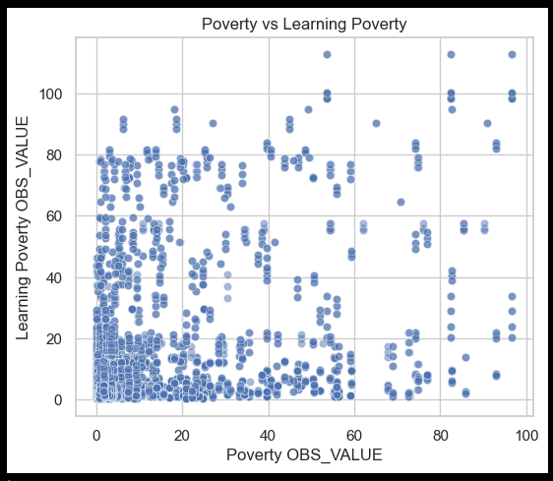
Line plot showing database average learning over time
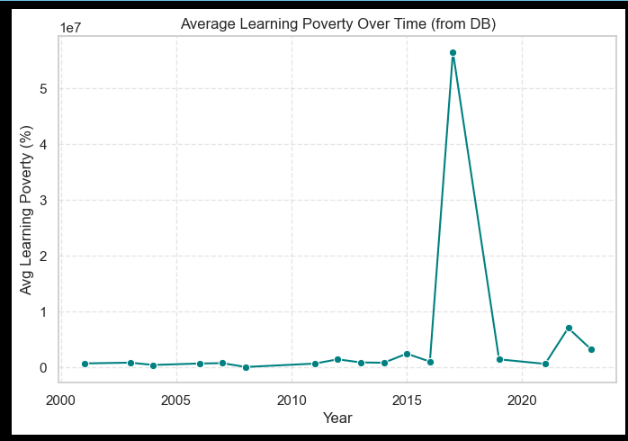
5. Analysis & Interpretation(insights)
6. Conclusion
7. References
- Fujs, T., Castaneda Aguilar, R.A., Edochie, I., Eilertsen, A., Nguyen, M.C., Wu, H. and Lakner, C., 2022. A new home for the World Bank’s global poverty and inequality data. [online] World Bank Blogs. Available at: https://blogs.worldbank.org/en/opendata/new-home-world-banks-global-poverty-and-inequality-data [Accessed 31 Aug. 2025].
- Tony Fujs, Aleksander Eilertsen, Ronak Shah and R. Andrés Castañeda (2022). pipr: Client for the PIP. API. https://github.com/worldbank/pipr , https://worldbank.github.io/pipr/.
- World Bank, n.d. Learning Poverty Global Database (LPGD). World Bank DataBank. Available at: https://databank.worldbank.org/source/learning-poverty

